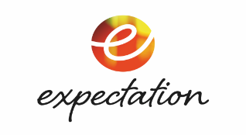
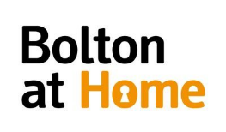
Sponsored by

Alma’s Not Normal Trainee Scheme Application 2021

All Applications must be received no later than Monday 15th March 2021

All Applicants must be:

- Eligible through the ‘Young Person NEET* Sponsorship Scheme’
- Over 18 years old
- Live in Bolton
- Have the right to work in the UK
*Not in Employment, Education or Training

The Trainee Work Scheme will be run between 19th April and 30th May 21
We are looking for a trainee who loves all things TV and wants to learn more about the industry. You don’t need any specific qualifications, media training or any previous TV experience to do this trainee paid job placement but you need bags of enthusiasm, a good brain and a can-do attitude. A commitment to participate in and complete the full trainee work scheme, which means a good work ethic, turning up on time!
Our trainees will work in specific departments across the programme including producing, art department, costume department, makeup department, camera department, location department, production department.
The work is full time, often up to 50 hours a week, and is paid at minimum age wage. The job will be based primarily in Bolton but will involve some filming in Manchester.
The deadline for this application is 15th March 2021
You will be notified by email if your application has been successful and will be invited to an interview. Interviews will take place on 24th March & 26th March 2021 via Zoom or Teams. If you have not heard from us by this date, please assume that your application has been unsuccessful.
Before you start to fill in this form, we would like to explain that the information you give in this form will be used by us to select candidates for the position of Trainees. Please read our Privacy Policy which details your rights with regards to your personal information: http://expectationentertainment.com/privacy-policy

This application form is the first stage of a possible selection process and that there is no guarantee that by completing this form you will be offered the opportunity to join the scheme.
PLEASE EMAIL COMPLETED FORMS TO
scriptedjobs@expectationtv.com
Name: |  | DOB:
Home Tel: |  | Mobile:
Email Address:

Bolton Post Code
No minimum or maximum word count, you can extend the boxes as needed. You are advised to be focused and provide details that demonstrate why you are the right candidate for this fantastic importunity as a trainee.
QUESTIONNAIRE
Tell us about who you are and what you currently do day to day:

Tell us about what made you apply for this trainee scheme:

Let us know what area of the industry you are interested in and why:
Producing, directing, costume, makeup, camera, art department, locations!

I confirm that: | Yes/No
I am eligible as a ‘Young Person NEET*’ Bolton applicant
*Not in Employment, Education or Training
Have the right to work in the UK

I consent to this personal data being processed and kept by Expectation TV and the programme distributor for the purpose of assessing my application in accordance with data protection legislation and guidelines. I confirm I have read and understood the privacy policy.
If you are not selected as a trainee on this scheme, this form and any copies will be destroyed following completion of the production. If you are selected as a trainee this form will be retained in line with our data retention policy.
I confirm that all the above information provided is accurate, truthful and not misleading.

Full Name ____________________________________________
(Block Caps)

Signature: ____________________________________________

Date: ____________________________________________

Please email to: scriptedjobs@expectationtv.com

The deadline for this application is 15th March 2021

